|  |  |
| --- | --- |
|  | Project WBS  Date: 30/09/2020 |

|  |  |  |  |
| --- | --- | --- | --- |
| Document History | | | |
| **Version** | **Date** | **Editor** | **Comment** |
| 0.1 | 30/09/2020 | Yusai | Create the document |
|  |  |  |  |
|  |  |  |  |
|  |  |  |  |

Table of Content

1 Project WBS overview 1

2 Project WBS 2

3 Project WBS dictionary 2

4 Approval and Authority to Proceed 5

# Project WBS overview

The WBS of this project mainly includes two parts. The first is to decompose the comprehensive management tasks related to the project from the perspective of a wide range of project management. This part of the content is carried out as the management work in the project execution process. The second part is the decomposition of project implementation tasks specific to this project, which is decomposed according to the background information and project characteristics of the project, and is reflected as the main task in the project schedule Gantt chart.

# Project WBS

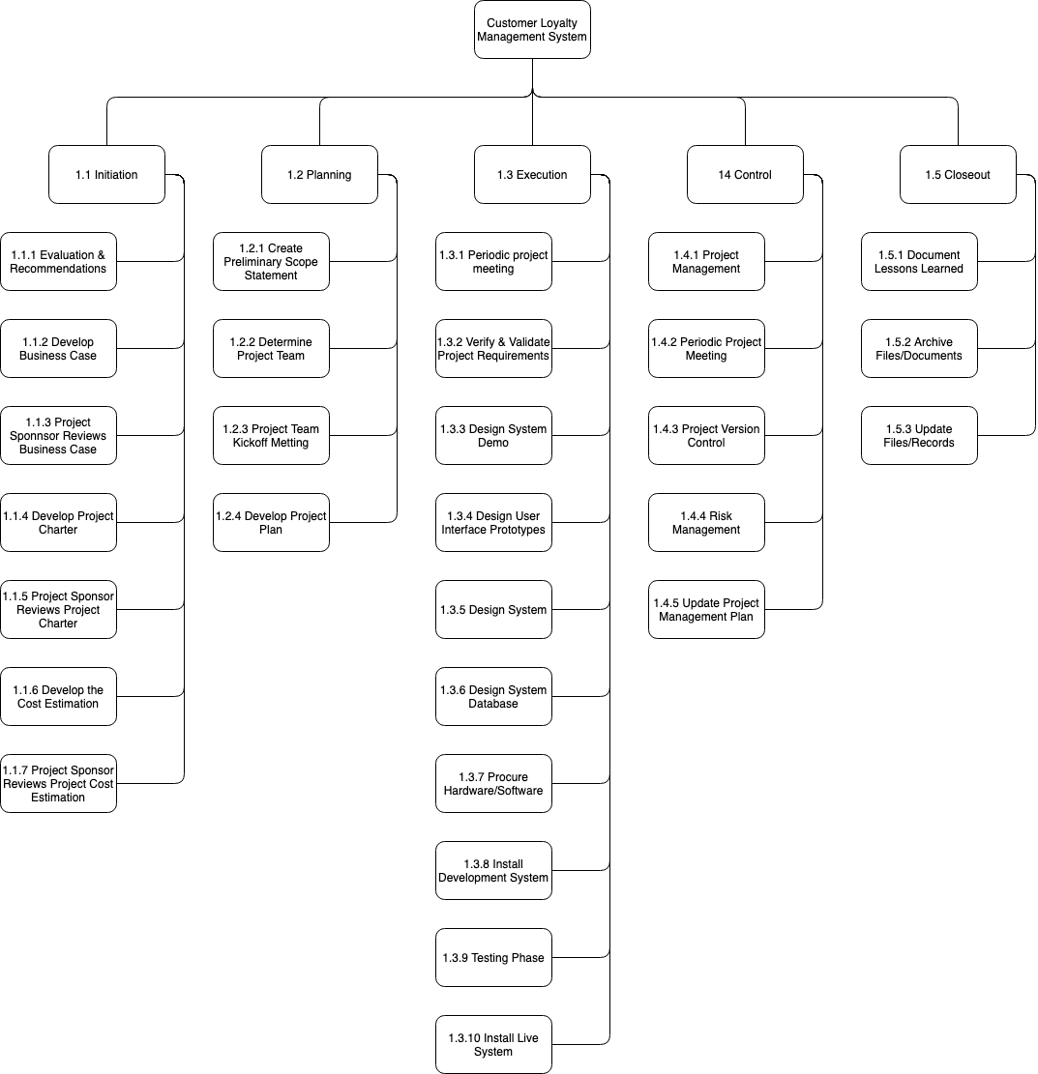

# Project WBS dictionary

**Note:** *The task which mark ‘*’ in the WBS dictionary as the management work covering the whole life cycle of the project, so it is not reflected in the project Gantt chart.*

| **Level** | **WBS Code** | **Element Name** | **Definition** |
| --- | --- | --- | --- |
| 1 | 1 | Customer Loyalty Management System | All work to implement a new Customer Loyalty Management System. |
| 2 | 1.1 | Initiation | The work to initiate the project. |
| 3 | 1.1.1 | Evaluation & Recommendations | Working group to evaluate solution sets and make recommendations. |
| 3 | 1.1.2 | Develop Business Case | Develop business cases for selected projects. |
| 3 | 1.1.3 | Project Sponsor Reviews Business Case | Project sponsor reviews the Business Case. |
| 3 | 1.1.4 | Develop Project Charter | Project Manager to develop the Project Charter. |
| 3 | 1.1.5 | Project Sponsor Reviews Project Charter | Project sponsor reviews the Project Charter. |
| 3 | 1.1.6 | Develop the Cost Estimation | Develop the Project Cost Estimation. |
| 3 | 1.1.7 | Project Sponsor Reviews Project Cost Estimation | Project sponsor reviews the Project Cost Estimation. |
| 2 | 1.2 | Planning | The work for the planning process for the project. |
| 3 | 1.2.1 | Create Preliminary Scope Statement | Project Manager creates a Preliminary Scope Statement. |
| 3 | 1.2.2 | Determine Project Team | The Project Manager determines the project team and requests the resources. |
| 3 | *1.2.3 | Project Team Kickoff Meeting | The planning process is officially started with a project kickoff meeting which includes the Project Manager, Project Team and Project Sponsor (optional). |
| 3 | 1.2.4 | Develop Project Plan | Under the direction of the Project Manager the team develops the project plan. |
| 2 | 1.3 | Execution | Work involved to execute the project. |
| 3 | *1.3.1 | Periodic project meeting | Project Manager conducts a formal periodic meeting with the project team, project stakeholders and project sponsor. |
| 3 | 1.3.2 | Verify & Validate Project Requirements | The original user requirements is reviewed by the project manager and team, then validated with the users/stakeholders. This is where additional clarification may be needed. |
| 3 | 1.3.3 | Design System Demo | The technical resources design the demo of Customer Loyalty Management System. |
| 3 | 1.3.4 | Design User Interface Prototypes | UI design based on user habits and system structure |
| 3 | 1.3.5 | Design System | The technical resources design the Customer Loyalty Management System. |
| 3 | 1.3.6 | Design System Database | The technical resources design the database of Customer Loyalty Management System. |
| 3 | 1.3.7 | Procure Hardware/Software | The procurement of all hardware, software and facility needs for the project. |
| 3 | 1.3.8 | Install Development System | Team installs a development system for testing and customizations of user interfaces. |
| 3 | 1.3.9 | Testing System | The system is tested with a select set of users. |
| 3 | 1.3.10 | Install Live System | The actual system is installed and configured. |
| 2 | 1.4 | Control | The work involved for the control process of the project. |
| 3 | *1.4.1 | Project Management | Overall project management for the project. |
| 3 | *1.4.2 | Periodic project meeting | Project Manager conducts a formal periodic meeting with the project team, project stakeholders and project sponsor. |
| 3 | *1.4.3 | Project version control | Use the GitHub to maintain the major project deliverables. |
| 3 | *1.4.4 | Risk Management | Risk management efforts as defined in the Risk Management Plan. |
| 3 | 1.4.5 | Update Project Management Plan | Project Manager updates the Project Management Plan as the project progresses. |
| 2 | 1.5 | Closeout | The work to close-out the project. |
| 3 | 1.5.1 | Document Lessons Learned | Project Manager along with the project team performs a lessons learned meeting and documents the lessons learned for the project. |
| 3 | 1.5.2 | Archive Files/Documents | All project related files and documents are formally archived. |
| 3 | 1.5.3 | Update Files/Records | All files and records are updated to reflect the Customer Loyalty Management System. |

# Approval and Authority to Proceed

We approve the project as described above, and authorize the team to proceed.

| Name | Title | Date |
| --- | --- | --- |
|  |  |  |
|  |  |  |
|  |  |  |